In this final project, I will attempt to measure the effects variables like duration and the legality of strikes have on both strike survival (in a survival analysis manner) and strike success in wage/collective bargaining based strike events, from strike events extracted from newspaper articles. So, this project will consist of three parts: Web scraping, event extraction & detection and survival analysis as well as logit analysis for success.

Starting off, I will be scraping all of the article contents, titles, website links and dates of articles in the Evrensel İşçi-Sendika category from the start of 2024 to December. This is a pretty standard webscraping script, which crawls through each page and first scrapes the title, data, link of each article. Then, it opens each article link and extracts the contents. One interesting thing is that I had to use the playwright api for scraping since it gets around Evrensel's firewall protection really well by "acting" as a real user. The downside is that webscraping in this manner takes a long time. After some light text cleaning, I export the results to an excel file. We ended up with 9186 articles and scraped their contents, titles, dates published and website links.

After scraping, we can move onto event detection & linking. My first idea was to extract the qualities we desired (such as union presence, number of workers on strike etc.) automatically from the articles. In this endeavour, I attempted to use sequential linking for both training the detection (using spans of a sentence in json format) and event linking. After producing very low evaluation scores (see sequence_linking_deneme.ipynb), I decided to manually annotate the spans using doccano. Unfortunately, doccano works terribly with Turkish; so that was a waste. I then gave up on automatic extraction completely, instead opting to manually label the relevant values for our linked events.

My next idea was annotating 738 of our articles by hand for their relevance (1 for relevant and 0 for irrelevant) and training the model on this set, with the majority of them being labeled negative (160 positive, 578 negative) as to reflect the pool of articles. Although training was fine, this approach lacked in event linking; producing huge clusters (see event detection & linking).

To overcome this, I attempted to use rule-based clustering for cross-document linking. However, because of normalization, tuning and rule errors; the model was not able to effectively link events (see detection_extraction_deneme3.ipynb)

Then, I tried to add a NER package to do the linking, but the Turkish depository could not be accessed (see detection_extraction_deneme4.ipynb).

Finally, after all these trials, we arrived at our last model. This model is very similar to our rule-based clustering approach, with measures to prevent mega clusters implemented. The details of this process will be explained duly..

For training, classic 20/80 test/train split was used. The model was trained on the 738 manually labeled rows as said before. We can observe that both the training and testing sets are balanced with respect to the distribution of 0/1's in around a 0.21 split for zeroes.

As specified in the midterm report, this project will not train a model from scratch; but modify and fine-tune BERTurk for strike detection purposes.

We trained the model on 3 epochs. We implemented the ROC-AUC score, since this is a binary classification task. We also weighed our trainer; since we value recall highly and relevant strikes are far less common than irrelevant ones in the article database.

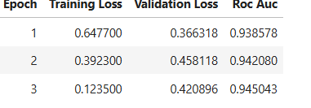

The ROC AUC score is highly promising, although the model is also somewhat prone to overfitting according to the validation loss over the epochs.

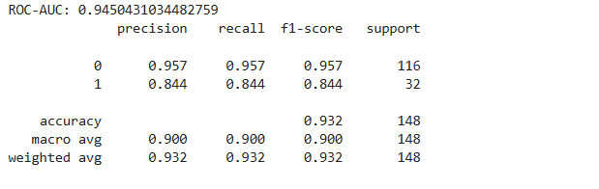

Our scores for 1's are lower than 0's, although they are still workable. This is likely because we have quite a small support in the validation set for 1's, with only 32 of them. Now, it istime for predictions. To not lose too many articles (since we prioritize recall as explained before), we picked a threshold that yields a minimum recall of 0.85. This ended up obviously being a low threshold.

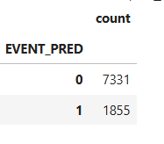

Out of the 9186 articles, our model has predicted 1855 of them to be strike relevant.
We know that we have 1855 strike-relevant articles. However, due to heavy semantic similarities, BERTurk cannot specifically detect wage/collective bargaining based strike events. Instead, it just detects "strike events" in general. So, we implemented some rules to narrow these 1855 articles down to wage/collective bargaining relevant ones.

At first, we had only CB_KEEP but later decided to split it into two parts: CB_KEEP_STRONG and CB_KEEP_WEAK. The reason is simple; CB_EXCLUDE was getting rid of too many articles (false negatives). You can find this version as a comment in the code. So, we had to relax our narrowing a bit. That is why we also added CB_DISMISSAL; we are not interested in strikes occurring because of dismissals but we do not want to lose the wage/collective bargaining strikes which also have workers dismissed. The CB_KEEP_STRONG and CB_KEEP_WEAK lists are self explanatory (relating to wage/collective bargaining). So is the CB_EXCLUDE, especially considering Evrensel's reporting tendencies.

So, we have reduced the wage/collective bargaining relevant articles to 1150 from the initial candidates of 1855.

Then, first we implemented some canonicalization (dropping suffixes, firm indicators etc) while also trying to fix broken encoding like "i ş" (this attempt will not work). Since we will be linking through employer/firm names, we must make sure that unwanted recurring tokens like union names, people names, any other junk and common Turkish words are not present. Although this list is not bad, as we will see, the issue of people names are very, very hard to overcome in Evrensel since for some reason; they record their reporters inside the text itself instead of having them as authors. Since no comprehensive list of reporters can be found (and since weird tokenizations mix some parts of the reporters' names with a part of the text), this part was appended by hand through trial and error and observing the most common results (this is actually the case for all of the lists but is especially true for person terms.).

After we arrived at our list, we started the phrase mining process for firm names. We built a candidate firm list by searching through the first 1200 characters of each text, using trigger and stop terms. Then, we dropped all the candidates that exist in our created lists from above. Through this process, we went from 2049 candidate phrases to keeping 951 firm phrases. We then tried to go even further and use a Turkish spaCy pipeline to extract canonicalized org_keys from our articles and to filter our organization keys.Through this process no docs were deleted, but this is not necessarily a bad thing. It likely helped with cleaning inside the articles. We then built regular expression patterns to specify employer and union keys separately instead of the "org_keys" we had before, which included both.

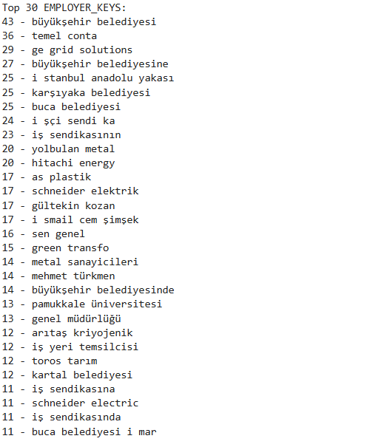

These are our top employer keys. Even though quite a lot of actual firms are present (temel conta, green transfo, hitachi energy); there are still person names (mehmet türkmen), canonicalization issues (schneider electric and schneider elektrik), nonsense unions (iş sendikasında) and broken tokenizations ( i şçi sendi ka) we could not get rid of.

After this, we loaded a multilingual sentence-transformer model to produce contextual embeddings to check for semantic similarity. In this endeavour, we built rare tokens for titles for extra linking evidence.

For linking, we used a safe time decay (to not completely miss strikes lasting a long time and hardly ever being reported on), employer buckets, similarity thresholds, rare token overlaps and trying for minimal clustering. The thresholds for our variables have been picked through many trial and errors in our re-runs.

We have 1150 articles, spread over 550 clusters with 441 unique employer keys. Although there is still one mega cluster, this will be solved when we firm split. This way, the events (articles) containing more than one firm will not fall under the same EVENT_ID now.

When we check how our detection performs with respect to our manually labeled data, we see that for wage/collective bargaining detection; we have extremely high recall but low precision as expected.
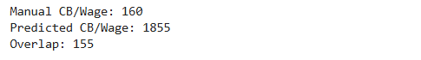
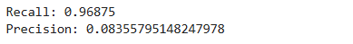

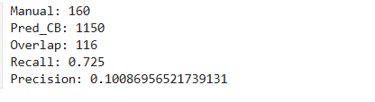

When we view the performance of our filtered data it seems our blocking rules are too strong, increasing precision slightly for a relatively big fall in recall. However, this is a necessary evil for getting rid of all the non collective bargaining events. In the end, I was left with 816 unique events encompassing 1151 articles. Manually, I was able to identify 134 unique events. So, our linking was still pretty subpar. For these unique events, I manually labeled "EVENT_ID","FIRM","WORKER_TOTAL","WORKER_STRIKE", "STRIKING_WORKER_RATIO","SECTOR","STRIKE_DURATION (DAYS)", "UNION_PRESENCE","LEGAL_STRIKE" and "RESULT". Both files can be seen at "firm_level_strikes_trigger_window(20)" and "Evrensel_2024_2025_found_strikes.xlsx" respectively. The columns are self explanatory ( "UNION_PRESENCE","LEGAL_STRIKE" and "RESULT" are binary variables) except when "RESULT" is blank, it means that the strike is ongoing/result unknown, and in this case "STRIKE_DURATION (DAYS)" indicates the strike duration up until the last date the strike was mentioned.

We finally arrive at the quantitative analysis part. As discussed before, we will work with a discrete-time hazard survival analysis model. Survival analysis works well with our objective since we want to know when/how strikes end. Also, discrete time hazard models already implement our "unknown" strikes by themselves by right-censoring. One downside is that since our event size is too small and there are not enough strikes that failed; we won't be able to use the discrete time hazard model for strike success; only for strike endings. For strike success, we will need to (unfortunately) use a logit model.

Since our STRIKING_WORKER_RATIO was percentages, we will normalize it to proportion. Also, we will scale WORKER_TOTAL since there are huge discrepancies among the strikes. We will also check covariates.

After we built the time bins, we then built the discrete time hazard model (using clusters) and fit our model to our data.

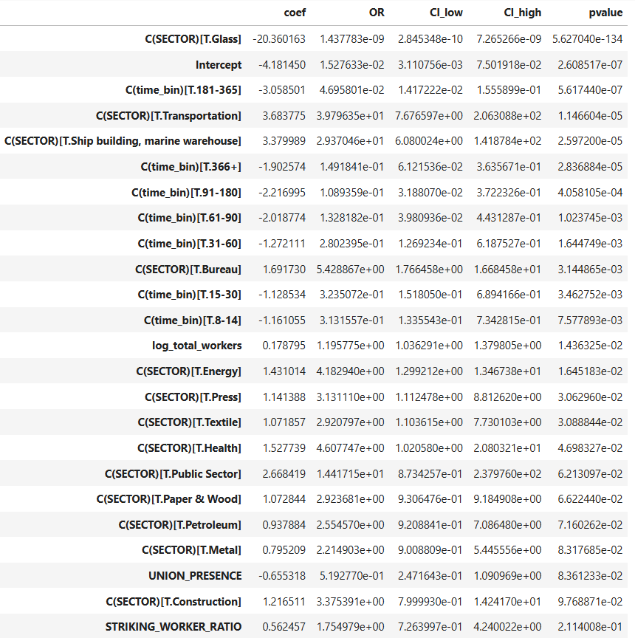
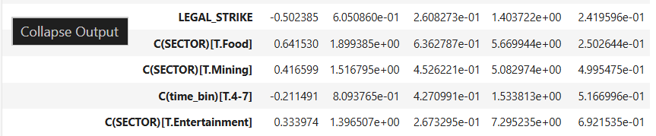
This is very informative. Let us start from the top. The OR of the glass sector indicates that there is a separation issue, there are simply not enough examples. Indeed, there are only 2 or 3 events of this type in our data. Thus, we must disregard it even if the p value is significant at the 1% level. For the time bins, we can see that OR levels are really low in the bucket 181-365 compared to the other buckets. This means, more or less, strikes getting through day 181 will most likely see day 365. On a more general note, we observe that strikes that get past 2 weeks become increasingly more unlikely to end on a given day. The OR scores of the other sectors show that the strikes most likely to end at any given day are in the transportation sector, with the least likely being the entertainment sector. The OR of log_workers point towards strikes at larger firms ending faster. Also it can be said that unionized strikes last longer, albeit with borderline significance. Surprisingly, neither the striking worker ratio nor the legality of strikes are statistically significant. The legality of strikes could be having filtered out by union presence and sectors (union presence most likely, since all legal strikes have to have a union).

We then add predicted hazards to construct a baseline hazard model to compare different variables.

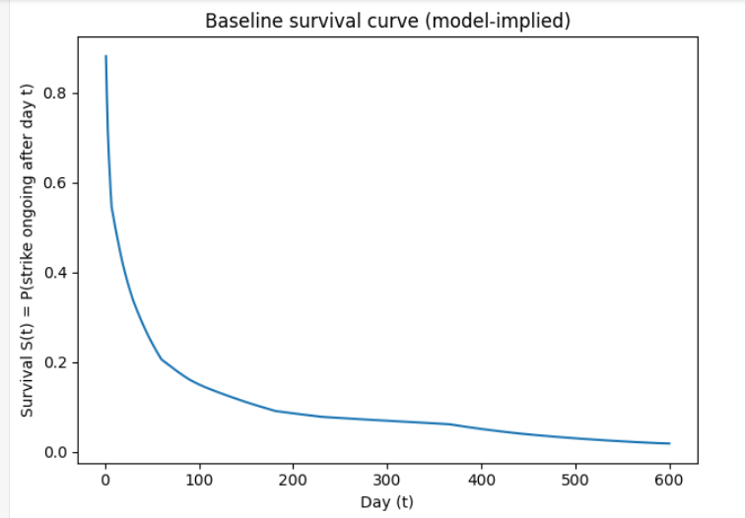

The visualization confirms our intuition: Low survival of strikes initially, high survival over time. Now, we will construct a counterfactual survival curve to measure different categories against one another, by constructing scenarios where all of the events are at that category and vice-versa.

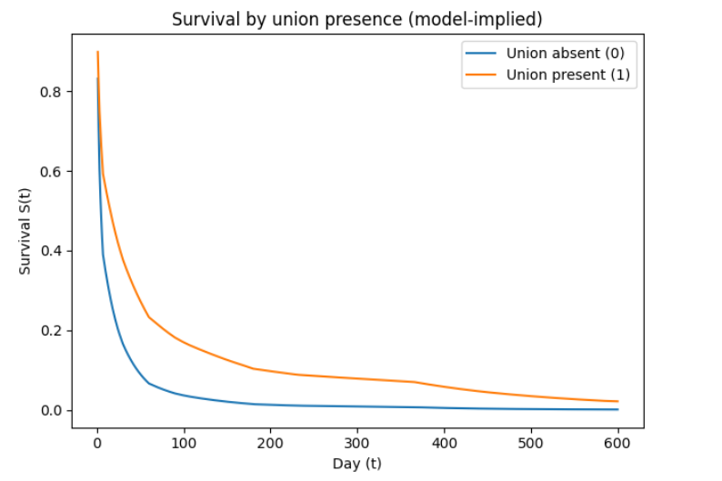
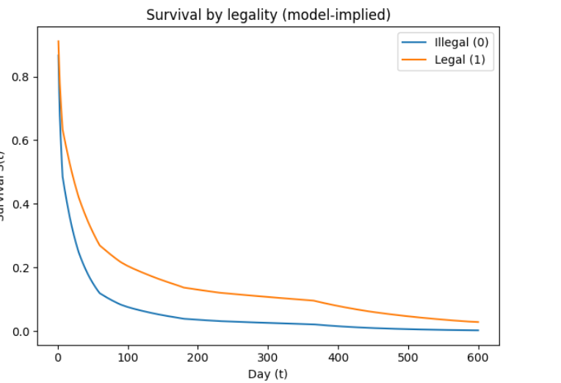
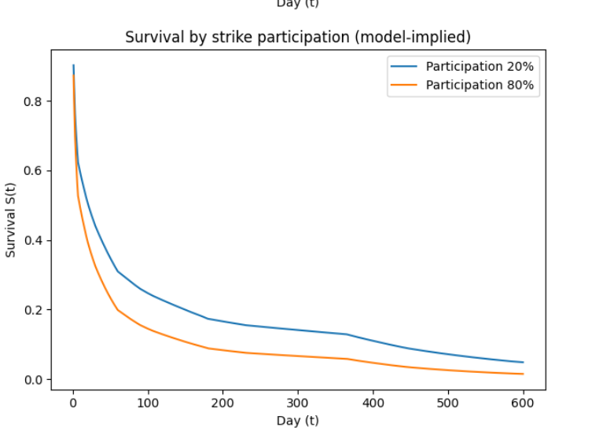

These results are highly informative. We can see that strikes with unions tend to survive better, legal strikes tend to survive better and lower participation tends to survive better. The first two we have talked about, what about the last one? One reason may be that low participation strikes usually don't affect the employer that much, so they just don't care; leaving the workers in a limbo where they are on strike until their strike eventually fizzles out.

We finally move onto the logit regression of strike success rates. Unfortunately, we have only 103 ended events. So, we should be careful about interpreting these statistics. Since our data is so small, we must collapse all sectors which have no variance to their results; since already their number is really low. After we drop from 16 to 6 sectors, we can fit our model.
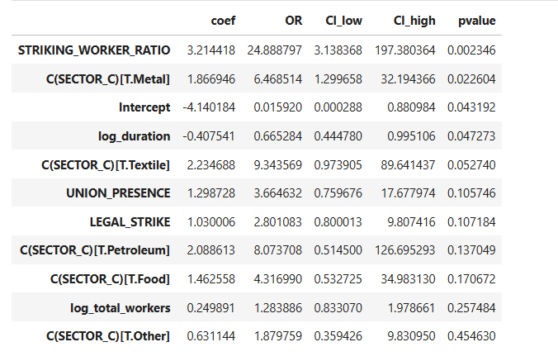
Now, what we have here is interesting. As expected, striking working ratio has a great effect on strike success rates at a significant level. Metal sector strikes are also associated with success. We can also see that as strikes go on, the probability of success decreases. Interestingly; both union presence and legal strike are not significant at the 10% level. This is highly a result of multicollinearity, since all legal strikes must have a union.

